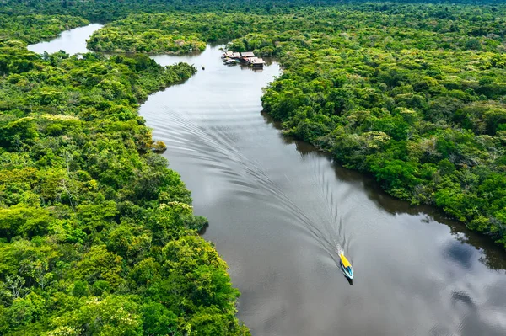


The Geography Curriculum at Lighthouse Schools Partnership

Geography at Lighthouse Schools Partnership


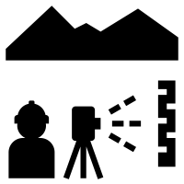
We believe that a high-quality geography education should inspire in pupils a curiosity and fascination about the world and its people that will remain with them for the rest of their lives.



Teaching should equip pupils with knowledge about diverse places, people, resources and natural and human environments, together with a deep understanding of the Earth’s key physical and human processes.

As pupils progress, their growing knowledge about the world should help them to deepen their understanding of the interaction between physical and human processes, and of the formation and use of landscapes and environments.


Geographical knowledge, understanding and skills provide the frameworks and approaches that explain how the Earth’s features at different scales are shaped, interconnected and change over time.

Our Geography curriculum aims to ensure that all pupils:

- develop contextual knowledge of the location of globally significant places, both terrestrial and marine, including their defining physical and human characteristics and how these provide a geographical context for understanding the actions of processes
- understand the processes that give rise to key physical and human geographical features of the world, how these are interdependent and how they bring about spatial variation and change over time

are competent in the geographical skills needed to:
- collect, analyse and communicate with a range of data gathered through experiences of fieldwork that deepen their understanding of geographical
- processes
- interpret a range of sources of geographical information, including maps, diagrams, globes, aerial photographs and Geographical Information Systems (GIS)
- communicate geographical information in a variety of ways, including through maps, numerical and quantitative skills and writing at length

An overview of progression through our vertical concepts

  Settlements and Land Use |   Physical Processes | 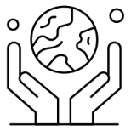  Environment and Sustainability
EYFS: Who are the people in the community who help us?  Pupils learn to identify important places and people in the community to understand what it means to have a job. They will create a simple map of the area near to the school and will learn how to cross the road safely. | LKS2: Why do people choose to live near volcanoes?  Pupils learn how mountains are formed and their features. They explain the formation and types of volcanoes before mapping the global distribution of mountains and volcanoes. They finish by considering the negative and positive effects of living in a volcanic environment. | KS1: What is it like at the North and South Poles?  Pupils will learn to locate the world’s coldest places at the North and South Poles. They will compare what it is like to live in the Arctic and Antarctic.
EYFS: What is it like in Kenya?  Pupils will learn about the weather and climate in Kenya comparing this to the UK. They will learn about the landscape and animals live of Kenya. Finally they will think about what is the same and different about the clothes people in Kenya wear compared to people in the UK. | LKS2: Why is water so important to us?  In this unit pupils will learn about the processes involved in the water cycle. They will learn about why water is essential for human life and how we meet the demand for a constant water supply in this country and others around the world. | KS1: Where are the hot climates in the world and what are they like?  Pupils will learn to locate the world’s hottest places including the tropical rainforests and hot deserts. They will compare the climate and location of these 2 hot places.
EYFS: What is it in the countryside/ in the town or city?  Pupils will learn about the features of a contrasting environment within the South West region comparing them with those where they live. | LKS2: What are rivers and how do they impact the lives of people?  Pupils will learn how rivers are formed and the landforms they create. They will learn about the impact of flooding in the UK and how humans are trying to reduce flooding. | LKS2: Why is the Amazon rainforest important to us?  Pupils will locate the Amazon rainforest and explain how the vegetation in a tropical rainforest is defined by the two Tropics. They will learn about the physical features and layers of the Amazon rainforest, learning about the food which comes from tropical rainforests. Pupils also learn about the people who live in the rainforest before thinking about how people are taking action to protect the rainforests.
KS1: Where do we go to school?  Pupils will use photographs and simple maps of the school to find and talk about the features of its site. Pupils will also use locational knowledge to talk about where things are and will understand what jobs people do in the school. | UKS2: How do earthquakes change the world?  Pupils learn about the causes of earthquakes, locating major earthquakes from recent history. Pupils learn about how people prepare and respond to earthquakes through studies of the 2011 Earthquake in Honshu, Japan and on Turkey in 2023. | UKS2: Where does our energy come from and how sustainably are we living?  Pupils learn about the advantages and disadvantages of renewable and non-renewable energy sources and the impacts these have on society, economy and environment. Pupils will also consider how sustainably people in their community are living and what steps can be taken to live and use energy more sustainably.
KS1: What is located near our school?  Pupils will describe physical features of different kinds of homes (including in the local area). They will locate the school on an aerial photograph looking for local features.  Pupils will go on a local walk and create a simple of map of the area around the school before completing a survey of how they get to school. |  | UKS2: Why are oceans important?  Exploring the significance of our oceans, pupils learn how humans use and impact them and how this has changed over time. Pupils study the Great Barrier Reef and how plastic and pollution is damaging this marine environment, before considering positive environmental changes that can be made including making eco-friendly choices.
KS1: How are countries in the UK different?  Pupils will name and locate countries and capitals of the UK including its surrounding seas. They will also compare and contrast the geographical features of England, Scotland, Wales and Northern Ireland. |  | UKS2: What is it like to live in the Mojave Desert?  Exploring biomes and their various characteristics, pupils study deserts, mapping those around the world but particularly focusing on those in North America. Pupils learn about the physical features of a desert and consider how humans interact with and have adapted to living in the desert.
KS1: How is life different in Jamaica?  Pupils will learn about the location of Jamaica, its surrounding sea and connection to the UK. They will learn about the climate of Jamaica as well as the human and physical features of this island including occupations in farming and tourism before comparing Kingston with their local area. |  | UKS2: How do we get our food and commodities in the UK?  Pupils will learn about the import and export of goods around the world focussing on commodities and manufactured goods. They will consider the global food chain evaluating the costs and benefits of this before considering ethical trading.
LKS2: How are settlements established and how do they grow?
Pupils will learn to recognise key features of villages, towns and cities locating these in atlases and OS maps. They will look at the location and growth of settlements considering their own locality and how it has changed over time.
LKS2: How is life different in Northern Italy?
Pupils will learn about the geographical features of Northern Italy and how this affects life for people living in both a village and town in this part of Europe. They will consider the impact of tourism on Venice and will compare life in Northern Italy to life in the South West.
UKS2: What challenges do people face living in favelas in Rio de Janeiro?
Pupils learn what an informal settlement is, why they develop and what it is like to live in one. They learn about the challenges that people face who live in informal settlements and how life can be improved.

Year group and term | Substantive Knowledge | Disciplinary Knowledge | Enquiry Question | Vertical Concepts
Nursery/ Reception  Autumn Term | The local area | Locational knowledge  Human and physical geography | Who are the people in the community who help us? | Settlements and land use
Nursery/ Reception  Spring Term | Life in Africa | Locational knowledge  Place knowledge  Human and physical geography | What is it like in Kenya? | Settlements and land use
Nursery/ Reception  Summer Term | Geographical features of the South West region | Locational knowledge  Human and physical geography | What is it like to live in the countryside/ in the city? | Settlements and land use
Year 1 Autumn Term | Our school | Human and physical geography  Geographical skills and fieldwork | Where do we go to school? | Settlements and land use
Year 1 Spring  Term | The local area | Locational knowledge  Human and physical geography  Geographical skills and fieldwork | What is located near our school? | Settlements and land use
Year 1 Summer  Term | Geographical features of the UK | Locational knowledge  Human and physical geography  Geographical skills | How are countries in the UK different? | Settlements and land use
Year 2 Autumn  Term | Cold climates | Locational knowledge  Human and physical geography  Geographical skills | What is it like at the North and South Poles? | Environment and sustainability
Year 2 Spring  Term | Hot climates | Locational knowledge  Human and physical geography  Geographical skills | Where are the hot climates in the world and what are they like? | Environment and sustainability
Year 2 Summer  Term | Life on a Caribbean Island | Locational knowledge  Place knowledge  Human and physical geography  Geographical skills | How is life different in Jamaica? | Settlements and land use
Year 3 Autumn  Term | Settlements/ our local area | Locational knowledge  Human and physical geography  Geographical skills and fieldwork | How are settlements established and how do they grow? | Settlements and land use
Year 3 Spring  Term | Mountains and volcanoes | Locational knowledge  Human and physical geography  Geographical skills | Why do people choose to live near volcanoes? | Physical processes
Year 3 Summer  Term | Life in a European country | Locational knowledge  Place knowledge  Human and physical geography  Geographical skills | How is life different in Northern Italy? | Settlements and land use
Year 4 Autumn  Term | The water cycle | Locational knowledge  Place knowledge  Human and physical geography  Geographical skills | Why is water so important? | Physical processes
Year 4 Spring  Term | Rivers | Locational knowledge  Place knowledge  Human and physical geography  Geographical skills and fieldwork | What are rivers and how do they impact the lives of people? | Physical processes
Year 4 Summer  Term | Amazon biome | Locational knowledge  Place knowledge  Human and physical geography  Geographical skills | Why is the Amazon rainforest important to us? | Environment and sustainability
Year 5 Autumn  Term | Informal settlements | Locational knowledge  Place knowledge  Human and physical geography  Geographical skills | What challenges do people face living in informal settlements in Rio de Janeiro ? | Settlements and land use
Year 5 Spring  Term | Earthquakes | Locational knowledge  Place knowledge  Human and physical geography  Geographical skills | How do earthquakes change the world? | Physical processes
Year 5 Summer  Term | Renewable and non-renewable energy | Locational knowledge  Place knowledge  Human and physical geography  Geographical fieldwork | Where does our energy come from? | Environment and sustainability
Year 6 Autumn  Term | Coral Biomes | Locational Knowledge  Human and Physical Geography  Geographical Skills | Why are oceans important? | Environment and sustainability
Year 6 Spring  Term | Desert Biomes | Locational Knowledge  Place Knowledge  Human and Physical Geography  Geographical knowledge | What is it like to live in the Mojave Desert? | Environment and sustainability
Year 6 Summer  Term | Global trade | Locational knowledge  Human and physical geography  Geographical skills and fieldwork | How do we get our food and commodities in the UK? | Environment and sustainability

Match to EYFS Profile

Statement from EYFS Profile | EYFS Autumn Term | EYFS Spring  Term | EYFS Summer Term
Talk about the lives of the people around them and their roles in society
Describe their immediate environment using knowledge from observation, discussion, stories, non-fiction texts, and maps
Explain some similarities and differences between life in this country and life in other countries, drawing on knowledge from stories, non-fiction texts and – when appropriate – maps
Explore the natural world around them, making observations and drawing pictures of animals and plants
Know some similarities and differences between the natural world around them and contrasting environments, drawing on their experiences and what has been read in class

Match to National Curriculum
Match to National Curriculum: Key Stage 1

 | National Curriculum Statements | Year 1 Block 1 | Year 1 Block 2 | Year 1  Block 3 | Year 2 Block 1 | Year 2  Block 2 | Year 2 Block 3
Locational Knowledge | Name and locate the world’s seven continents and five oceans
Locational Knowledge | Name, locate and identify characteristics of the four countries and capital cities of  the United Kingdom and its surrounding seas
Place Knowledge | Understand geographical similarities and differences through studying the human  and physical geography of a small area of the United Kingdom, and of a small area in  a contrasting non-European country
Human and Physical | Identify seasonal and daily weather patterns in the United Kingdom and the location of hot and cold areas of the world in relation to the Equator and the North and South Poles
Human and Physical | Use basic geographical vocabulary to refer to: key physical features, including: beach, cliff, coast, forest, hill, mountain, sea, ocean, river, soil, valley, vegetation, season and weather
Human and Physical | Use basic geographical vocabulary to refer to: key human features, including: city,  town, village, factory, farm, house, office, port, harbour and shop
Geographical skills and fieldwork | use world maps, atlases and globes to identify the United Kingdom and its countries,  as well as the countries, continents and oceans studied at this key stage
Geographical skills and fieldwork | use simple compass directions (North, South, East and West) and locational and directional language [for example, near and far; left and right], to describe the location of features and routes on a map
Geographical skills and fieldwork | use aerial photographs and plan perspectives to recognise landmarks and basic human and physical features; devise a simple map; and use and construct basic symbols in a key
Geographical skills and fieldwork | use simple fieldwork and observational skills to study the geography of their school  and its grounds and the key human and physical features of its surrounding environment

Match to National Curriculum: Lower Key Stage 2

 | National Curriculum Statements | Year 3 Block 1 | Year 3 Block 2 | Year 3 Block 3 | Year 4 Block 1 | Year 4 Block 2 | Year 4 Block 3
Locational Knowledge | locate the world’s countries, using maps to focus on Europe (including the location of Russia) and North and South America, concentrating on their environmental regions, key physical and human characteristics, countries, and major cities
Locational Knowledge | name and locate counties and cities of the United Kingdom, geographical regions and their identifying human and physical characteristics, key topographical features (including hills, mountains, coasts and rivers), and land-use patterns; and understand how some of these aspects have changed over time
Locational Knowledge | identify the position and significance of latitude, longitude, Equator, Northern Hemisphere, Southern Hemisphere, the Tropics of Cancer and Capricorn, Arctic and Antarctic Circle, the Prime/Greenwich Meridian and time zones (including day and night)
Place Knowledge | understand geographical similarities and differences through the study of human and physical geography of a region of the United Kingdom, a region in a European country, and a region within North or South America
Human and Physical | describe and understand key aspects of: physical geography, including: climate zones, biomes and vegetation belts, rivers, mountains, volcanoes and earthquakes, and the water cycle
Human and Physical | describe and understand key aspects of: human geography, including: types of settlement and land use, economic activity including trade links, and the distribution of natural resources including energy, food, minerals and water
Geographical skills and fieldwork | use maps, atlases, globes and digital/computer mapping to locate countries and describe features studied
Geographical skills and fieldwork | use the eight points of a compass, four and six-figure grid references, symbols and key (including the use of Ordnance Survey maps) to build their knowledge of the United Kingdom and the wider world
Geographical skills and fieldwork | use fieldwork to observe, measure, record and present the human and physical features in the local area using a range of methods, including sketch maps, plans and graphs, and digital technologies

Match to National Curriculum: Upper Key Stage 2

 | National Curriculum Statements | Year 5 Block 1 | Year 5 Block 2 | Year 5 Block 3 | Year 6 Block 1 | Year 6 Block 2 | Year 6 Block 3
Locational Knowledge | locate the world’s countries, using maps to focus on Europe (including the location of Russia) and North and South America, concentrating on their environmental regions, key physical and human characteristics, countries, and major cities
Locational Knowledge | name and locate counties and cities of the United Kingdom, geographical regions and their identifying human and physical characteristics, key topographical features (including hills, mountains, coasts and rivers), and land-use patterns; and understand how some of these aspects have changed over time
Locational Knowledge | identify the position and significance of latitude, longitude, Equator, Northern Hemisphere, Southern Hemisphere, the Tropics of Cancer and Capricorn, Arctic and Antarctic Circle, the Prime/Greenwich Meridian and time zones (including day and night)
Place Knowledge | understand geographical similarities and differences through the study of human and physical geography of a region of the United Kingdom, a region in a European country, and a region within North or South America
Human and Physical | describe and understand key aspects of: physical geography, including: climate zones, biomes and vegetation belts, rivers, mountains, volcanoes and earthquakes, and the water cycle
Human and Physical | describe and understand key aspects of: human geography, including: types of settlement and land use, economic activity including trade links, and the distribution of natural resources including energy, food, minerals and water
Geographical skills and fieldwork | use maps, atlases, globes and digital/computer mapping to locate countries and describe features studied
Geographical skills and fieldwork | use the eight points of a compass, four and six-figure grid references, symbols and key (including the use of Ordnance Survey maps) to build their knowledge of the United Kingdom and the wider world
Geographical skills and fieldwork | use fieldwork to observe, measure, record and present the human and physical features in the local area using a range of methods, including sketch maps, plans and graphs, and digital technologies

Progression of skills within the Geography Curriculum
Medium term plans define the substantive knowledge which should be learnt during the course of each unit. In addition, disciplinary skills are also defined; these are used, deliberately practiced and developed in order for pupils to understand how historians work and how we learn about, and from, the past. These skills are broken down by phase and are integral to rich learning in Geography. As these skills are used in each unit, pupils will become more and more skilled and confident in their use of them as they will have 6 opportunities across their time in each phase to develop competency before moving into the next stage of learning.


People, Culture and Communities
Nursery (3 and 4) | Reception | ELG
- Show interest in different occupations  - Know that there are different countries in the world and talk about the differences they have experienced or seen in photos | - Talk about members of their immediate family and community  - Name and describe people who are familiar to them  - Draw information from a simple map  - Understand that some places are special to members of their community  - Recognise some similarities and differences between life in this country and life in other countries  - Explore the natural world around them  - Describe what they see, hear and feel whilst outside  - Recognise some environments that are different from the one in which they live  - Understand the effect of changing seasons on the natural world around them | Children at the expected level of development will:  - Talk about the lives of the people around them and their roles in society  - Describe their immediate environment using knowledge from observation, discussion, stories, non-fiction texts, and maps  - Explain some similarities and differences between life in this country and life in other countries, drawing on knowledge from stories, non-fiction texts and – when appropriate – maps  - Explore the natural world around them, making observations and drawing pictures of animals and plants  - Know some similarities and differences between the natural world around them and contrasting environments, drawing on their experiences and what has been read in class
Communication – listening and attention
Nursery (3 and 4) | Reception | ELG
- Enjoy listening to longer stories and can remember much of what happens  - Understand ‘why’ questions, like: “Why do you think the caterpillar got so fat?” | - Understand how to listen carefully and why listening is important  - Learn new vocabulary  - Listen to and talk about stories to build familiarity and understanding  - Listen to and talk about selected non-fiction to develop a deep familiarity with new knowledge and vocabulary | Children at the expected level of development will:  - Listen attentively and respond to what they hear with relevant questions, comments and actions when being read to and during whole class discussions and small group interactions  - Make comments about what they have heard and ask questions to clarify their understanding  - Hold conversation when engaged in back-and-forth exchanges with their teacher and peers
Communication – speaking
Nursery (3 and 4) | Reception | ELG
- Use a wider range of vocabulary  - Use longer sentences of four to six words.  - Develop their communication but may continue to have problems with irregular tenses and plurals, such as ‘runned’ for ‘ran’, ‘swimmed’ for ‘swam’  - Be able to express a point of view and to debate when they disagree with an adult or a friend, using words as well as actions  - Start a conversation with an adult or a friend and continue it for many turns  - Use talk to organise themselves and their  play: “Let’s go on a bus... you sit there... I’ll be the driver.” | - Use new vocabulary through the day  - Ask questions to find out more and to check they understand what has been said to them  - Articulate their ideas and thoughts in well-formed sentences  - Connect one idea or action to another using a range of connectives  - Describe events in some detail  - Use talk to help work out problems and organise thinking and activities, and to explain how things work and why they might happen.  - Engage in non-fiction books | Children at the expected level of development will:  - Participate in small group, class and one-to-one discussions, offering their own ideas, using recently introduced vocabulary  - Offer explanations for why things might happen, making use of recently introduced vocabulary from stories, non-fiction, rhymes and poems when appropriate  - Express their ideas and feelings about their experiences using full sentences, including use of past, present, and future tenses and making use of conjunctions, with modelling and support from their teacher.
Mapping
Year 1 and 2 | Year 3 and 4 | Year 5 and 6
- Use a range of maps and globes (including picture maps) at different scales  - Use vocabulary such as bigger/smaller, near/far  - Know that maps give information about places in the world (where/what?)  - Locate land and sea on maps  - Use large scale maps and aerial photos of the school and local area  - Recognise simple features on maps e.g. buildings, roads and fields  - Follow a route on a map starting with a picture map of the school  - Recognise that maps need titles  - Recognise landmarks and basic human features on aerial photos  - Know which direction is North on an OS map  - Draw a simple map e.g. of a garden, route map, place in a story  - Use and construct basic symbols in a map key  - Know that symbols mean something on maps  - Find a given OS symbol on a map with support  - Begin to realise why maps need a key  - Look down on objects and make a plan e.g. of the classroom or playground | - Use a wider range of maps (including digital), atlases and globes to locate countries and features studied  - Use maps and diagrams from a range of publications e.g. holiday brochures, leaflets, town plans  - Use maps at more than one scale  - Recognise that larger scale maps cover less area  - Make and use simple route maps  - Recognise patterns on maps and begin to explain what they show  - Use the index and contents page of atlases.  - Label maps with titles to show their purpose  - Recognise that contours show height and slope.  - Use 4 figure coordinates to locate features on maps  - Create maps of small areas with features in the correct place  - Use plan views  - Recognise some standard OS symbols  - Link features on maps to photos and aerial views  - Make a simple scaled drawing e.g. of the classroom  - Use a scale bar to calculate some distances  - Relate measurement on large scale maps to measurements outside | - Use a wide range of maps, atlases, globes and digital maps to locate countries and features studied  - Relate different maps to each other and to aerial photos  - Begin to understand the differences between maps e.g. Google maps vs. Google Earth, and OS maps  - Choose the most appropriate map/globe for a specific purpose  - Follow routes on maps describing what can be seen  - Interpret and use thematic maps  - Understand that purpose, scale, symbols and style are related  - Recognise different map projections  - Identify, describe and interpret relief features on OS maps  - Use six figure coordinates  - Use latitude/longitude in a globe or atlas  - Create sketch maps using symbols and a key  - Use a wider range of OS symbols including 1:50K symbols  - Know that different scale OS maps use some different symbols  - Use models and maps to discuss land shape i.e. contours and slopes  Use the scale bar on maps  - Read and compare map scales  - Draw measured plans

Field Work and Enquiry
Year 1 and 2 | Year 3 and 4 | Year 5 and 6
- Use simple fieldwork techniques such as observation and identification to study the geography of the school and its grounds as well as the key human and physical features of its surrounding environment  - Use cameras and audio equipment to record geographical features, changes, and differences e.g. weather, seasons, vegetation, buildings etc  - Use simple compass directions (NSEW)  - Use locational and directional language to describe feature and routes e.g. left/right, forwards and backwards  - Use aerial photos and plan perspectives to recognise landmarks and basic human and physical features  - Ask simple geographical, ‘where?’, ‘what?’, and ‘who?’ questions about the world and their environment e.g. ‘What is it like to live in this place?’  - Investigate through observation and description  - Recognise differences between their own and others’ lives | - Use the eight points of a compass  - Observe, measure and record the human and physical features in the local area using a range of methods including sketch maps, cameras and other digital devices  - Make links between features observed in the environment to those on maps and aerial photos  - Ask more searching questions including, ‘how?’ and, ‘why? as well as, ‘where?’ and ‘what?’ when investigating places and processes  - Make comparisons with their own lives and their own situation  - Show increasing empathy and describe similarities as well as differences | - Use eight cardinal points to give directions and instructions  - Observe, measure and record human and physical features using a range of methods including sketch maps, cameras and other digital technologies e.g. data loggers to record (e.g. weather) at different times and in different places  - Interpret data collected and present the information in a variety of ways including charts and graphs  - Ask and answer questions that are more causal e.g. Why is that happening in that place? Could it happen here? What happened in the past to cause that? How is it likely change in the future?  - Make predictions and test simple hypotheses about people and places

Communication
Year 1 and 2 | Year 3 and 4 | Year 5 and 6
- Speak and write about, draw, observe and describe simple geographical concepts such as what they can see where  - Notice and describe patterns  - Interpret and create meaningful labels and symbols for a range of places both in and outside the classroom  - Use basic geographical vocabulary from the PoS (above) as well as to describe specific local geographical features (tube station, canal etc.)  - Give and follow simple instructions to get from one place to another using positional and directional language such as near, far, left and right  - Use maps and other images to talk about everyday life e.g. where we live, journey to school etc. | - Identify and describe geographical features, processes (changes), and patterns  - Use geographical language relating to the physical and human processes detailed in the PoS e.g. tributary and source when learning about rivers.  - Communicate geographical information through a range of methods including sketch maps, plans, graphs and presentations  - Express opinions and personal views about what they like and don’t like about specific geographical features and situations e.g. a proposed local wind farm | - Identify and explain increasing complex geographical features, processes (changes), patterns, relationships and ideas  - Use more precise geographical language relating to the physical and human processes detailed in the PoS e.g. tundra, coniferous/deciduous forest when learning about biomes  - Communicate geographical information in a variety of ways including through maps, diagrams, numerical and quantitative skills and writing at increasing length  - Develop their views and attitudes to critically evaluate responses to local geographical issues or events in the news e.g. for/against arguments relating to the proposed wind farm

Planning and delivering the curriculum

All units within the curriculum are planned around an enquiry question that pupils will answer by the end of the unit of work as a result of direct instruction, guided practice and independent application. All lessons have been intentionally chosen and sequence to support pupils to develop a rich schema within the unit being taught and the overall concept over time. This means that sequences of learning are carefully designed to ensure that the identified knowledge is focussed within the geographical concept being taught and stops us from teaching a surface level fact file on the rainforest or teaching a meaningless collection of facts about Italy.

The aim of every unit within our geography curriculum is to produce a final outcome that answers the enquiry question. This final piece enables pupils to showcase what they know and have learnt through the unit of work, using their own words. Final outcomes may be: a discussion or debate, a presentation or a written outcome.
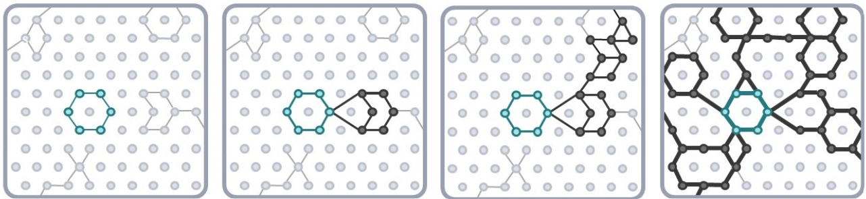
.

An illustration of how knowledge and understanding builds across a unit and over time through our units of work

A journey through the LKS2 unit ‘Why is the Amazon rainforest important to us?’

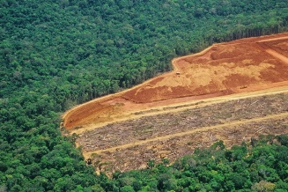
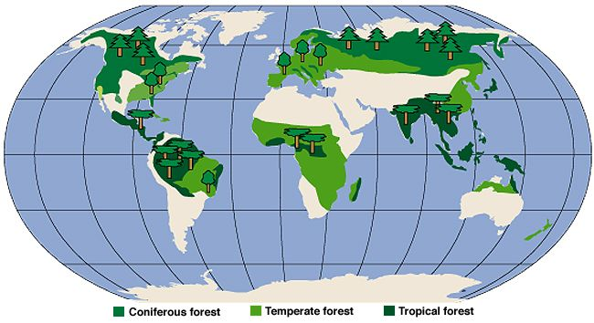
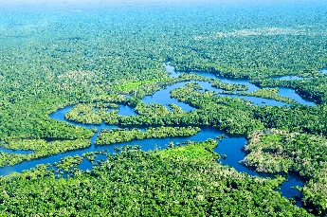

Applying the LSP pedagogy to geography
At LSP our pedagogical approach is based on Barak Rosenshine’s Principles of Instruction. All lessons in the geography curriculum are designed to be taught using this approach because when skilfully applied this will ensure that every pupil receives high quality, evidence informed teaching in every lesson, every day.

Our core pedagogical approach includes but is not limited to:

- A rigorous and sequential approach to the curriculum with a long-term approach to learning over time.
- All staff demonstrating through actions a culture of belief that everyone can achieve, succeed and master the taught programme of study.
- Teaching and learning which draws on cognitive learning theory and is demonstrated through action.
- An explicit instruction approach to teaching and learning which is implemented consistently and reflectively by all members of staff to enable mastery of the taught programme of study
- Use of ‘ I do, we do, you do’. This will ensure that children are clear what they need to do; have been shown how to do it; have appropriate scaffolds when needed and receive effective feedback to keep on track.
- Carefully planned adaptations to teaching and learning for those who need this.
- Regular, reflective, purposeful use of assessment for learning to ensure that teaching is effective so that children are successful.
- Active engagement and participation of all pupil throughout the learning journey.
- A collective approach to ensuring that children ‘keep-up’ with their learning as a result of well-planned and strategically implemented high-quality instruction.
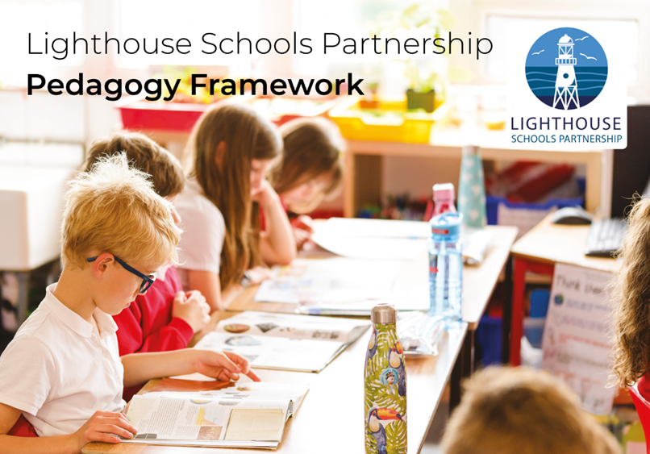
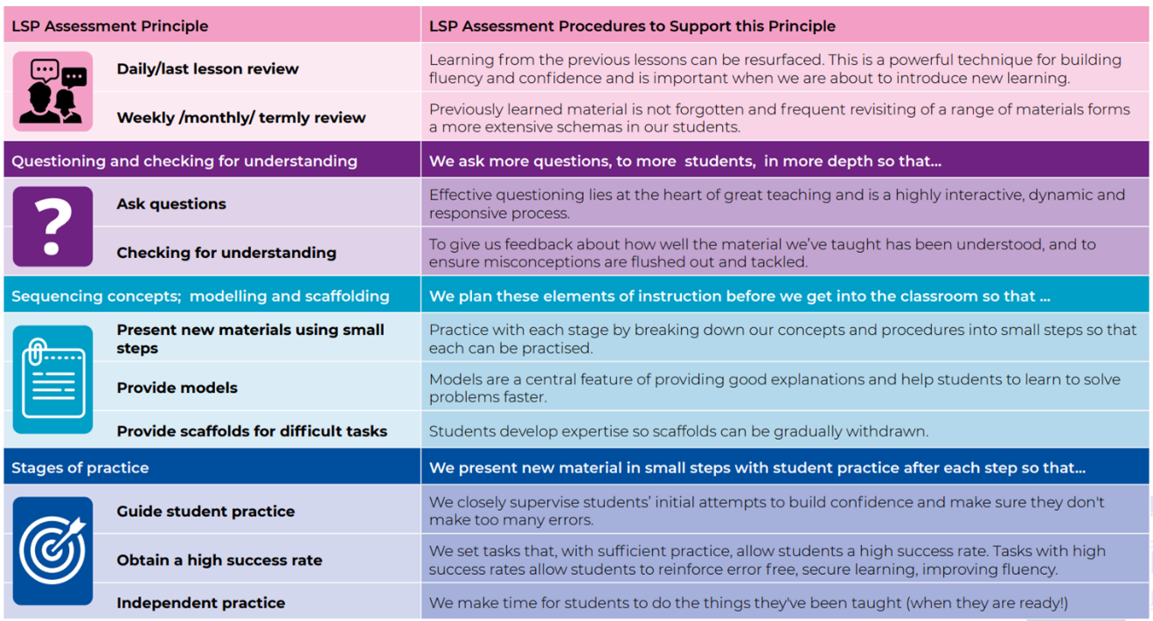

Retrieval practice
In LSP Geography lessons every lesson begins with a 5-10 minutes (including feedback) ‘Do Now’ activity. This is a retrieval practice starter based on the current and previous units of work. The principle of this is based on practicing what we did yesterday, earlier this week, last week and in the last unit.
Pupils complete these activities on whiteboards before moving on to the main session.
Knowledge organisers
Every unit of work has a pupil knowledge organiser, this is one of the resources which teachers use deliberately with pupils as part of the approach to practice and retrieval. It is recommended that the knowledge organiser is stuck into the Geography book at the beginning of a unit. These demarcates the beginning of the unit and means it is an accessible document for pupils during the unit. Knowledge organisers contain key information that children should have learnt by the end of a learning sequence, and contain key images; therefore, they act as a tool in supporting pupils to retain and retrieve knowledge and build a secure schema. They are designed to be quizzable (to build connections across knowledge rather than facts in isolation) and should be used with pupils during the unit particularly as part of ‘Do Now’s’ and during assessments at the end of the unit.
Assessment within geography
Assessment should check that curriculum content is learnt and committed to long-term memory. Pupils should be able to demonstrate that they know more, remember more and are able to do more as a result of the explicit teaching they have encountered. Teachers should use formative and summative assessment to build an understanding of pupil’s prior knowledge and performance to help draw out common misconceptions or gaps which can be addressed in future curriculum planning and delivery.
When assessment and feedback is sharply focused on the curriculum, and used as a tool of good pedagogy, teachers can maximise its value to improve the responsiveness of their teaching. This is important because we need to capture information on pupil achievement of the range of historical knowledge and skills that pupils will have been taught and have learnt within the context and concept being studied.

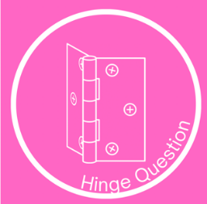




Regular formative assessment
Throughout units it is essential that teachers regularly check for understanding using a range of strategies. This enables teachers to identify gaps in pupils knowledge and understanding so they can respond in an appropriate way to secure achievement of core concepts, knowledge and skills. Lessons across units have been intentionally designed so that:
- pupils engage in regular low stakes testing of knowledge and deliberate practise of skills taught to date. This takes place at the beginning of each lesson through ‘do now’ tasks. These tasks have been crafted so that pupils retrieve knowledge from previous lessons and units; as a result, knowledge is more likely to embed in pupils long-term memory.
- teachers use a variety of ways to make sure that pupils are keeping up with the learning through opportunities for cold calling, think, pair, share, hinge questions and white board work etc. Teachers use the information gained to make in the moment decisions about next steps so that learning sequences can be adapted appropriately.
- pupils engage in ‘exit tickets’ based on knowledge gained during the session. This is another way to engage in low stakes quizzes or to make links in learning within and across sessions.
At the end of each session teachers review learning including outcomes produced by individuals, groups and the class as a whole and use this information to inform future sessions to ensure that pupils stay ‘on track’ throughout the unit.
Summative assessment
Summative assessment in Geography allows teachers to identify whether curriculum goals have been achieved. When a unit of learning is completed, teachers collect and connect the information and evidence gained from: outcomes produced in sessions over time; active engagement and demonstration of understanding in lessons to assess whether pupils have achieved the defined knowledge and skills within the concept for the taught unit.
In Geography, pupils also work to produce a final outcome which allows them to demonstrate to what extent they have achieved the specified knowledge and skills set out in the medium term plan for the unit.
Information gained from these sources is used by the teacher to record using the assessment tracking grids pupils who are working at or above the age related expectations.
Adapting the curriculum for pupils with SEND in Geography

We believe that all pupils should be able to access a full curriculum offer. Teachers make adaptions for pupils with SEND based on knowledge of the pupils needs and in line with individual target plans. Examples of adaptions which may be taken include but are not limited to:

- Adaptive teaching takes place.
- For sensory or physically impaired pupils, Geography learning may necessitate enlarging texts, using clear fonts, using visual overlays, or audio description of images.
- Dyslexic pupils may benefit from well-spaced print.
- Teachers identify and break down the components of the subject curriculum into manageable chunks for pupils who find learning more difficult, particularly those with cognition and learning needs. These may be smaller ‘steps’ than those taken by other pupils to avoid overloading the working memory.
- A variety of additional scaffolds may be used in lessons, such vocabulary banks, additional visual stimuli or adult support.

